INDIANAPOLIS ROSE SOCIETY ROSES FOR SPRING 2023

Shrub Roses
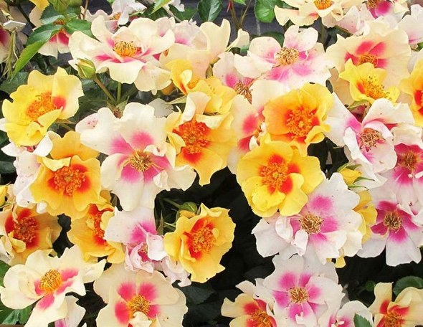
RINGO Shrub Rose (2018 +)
Zone 4-8 by Christopher Warner, UK, 2006
Height: Silver Certificate Hague Rose Trials 2017
3-4' New Zealand Rose Trials 2016, Novelty Award
Spread: First Prize Lyon Rose Trials 2015…
3-4'
Proven Winners® Shrub – a profusion of single or semi-double golden yellow blooms with a distinctive red ring at the center and yellow stamens, fading to a light yellow or cream with a pink central. Low maintenance, cold hardy and disease resistant, so easy to grow. Flowers all summer until frost without deadheading. Mutliple Awards!
https://www.provenwinners.com/plants/rosa/ringo-rose-rosa-x
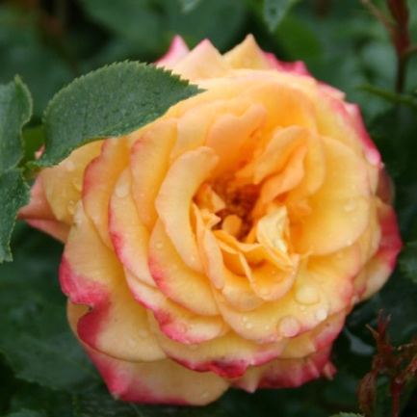
https://www.gardenia.net/plant/rosa-ringo
Suñorita Shrub Rose (2019 +)
Zone 5-9 by Christopher Warner,UK, 2006
Height: 2022 Rose of the Year
3-4'
Spread:
3-4'
Proven Winners® Shrub - Upright habit, red orange buds open to fuschia petals blending to soft apricot near center. Medium double blooms with exceptional citrus fruity strong fragrance, nearly thornless,
https://lincolnnurseries.com/plant/R3140/
https://www.provenwinners.com/plants/rosa/su-orita-rose-rosa-x
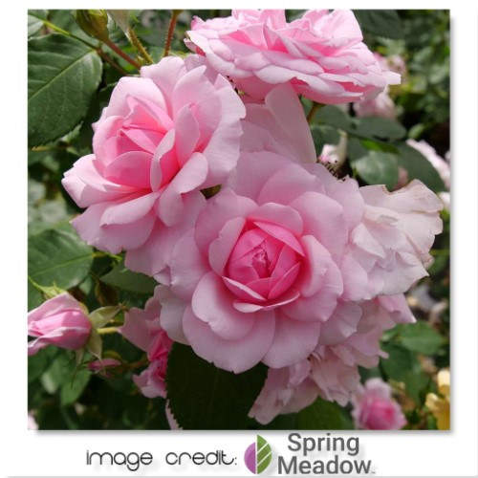
Pink Reminiscent Shrub Rose NEW
Zone 4-9 by Pheno Geno Roses, Serbia
Height:
3-4'
Spread:
1½-2'
Proven Winners Reminiscent™ roses represent a new day for rose lovers, combining the classic beauty and fragrance of old-fashioned roses with modern-day performance. from Proven Winners® Pale pink flowers, dark green foliage. Fragrant, disease resistant, heat tolerant, blooms all summer without deadheading
https://lincolnnurseries.com/plant/R3304/
https://www.provenwinners.com/plants/rosa/reminiscent-pink-rose-rosa-x
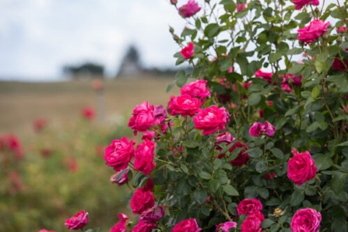
My Girl – EASY ELEGANCE Shrub Rose (2008 8.1)
Zone 4-9 by Peter Ping Lim 1997
Height:
3-5'
Spread:
3½-5'
Adorable, round, deep pink buds are held in cluster of 5 to 30, opening to 2½” ruffly blossoms so full, 25-30 petals, they almost hide the centers. Backed by medium green foliage, recurrent bloom, proven to be highly resistant to black spot with little to no defoliation.
https://easyeleganceroses.com/product/my-girl-rose/
https://lincolnnurseries.com/plant/a0042/
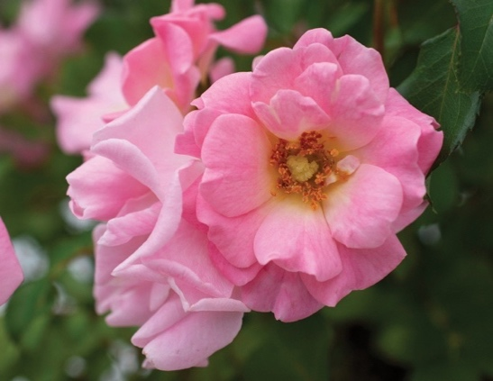
Drift Roses
BLUSHING DRIFT – Groundcover Rose (2017 8.0)
Zone 4-11 by Alain Meilland
Height:
1-1½'
Spread:
2-3'
Drift® stunning groundcover roses made easy®. Compact roses perfect for every size space. Blushing Drift® displays attractive double, pink flower clusters with a warm, yellow center, 25 petals, dark green very glossy foliage, slight fragrance. Blooms Spring-Frost, Excellent Disease Resistance, For Hillsides & Open Areas
https://www.starrosesandplants.com/plants/blushing-drift-rose/
https://lincolnnurseries.com/plant/r0085/
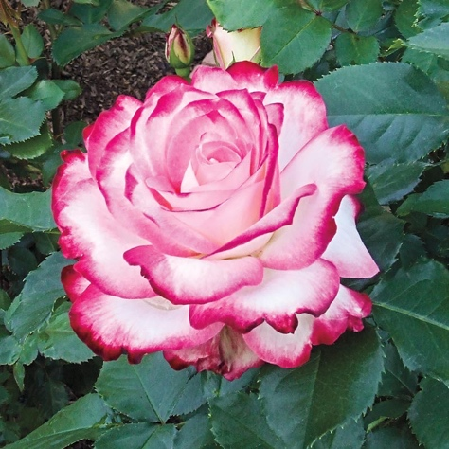
Grandiflora
Cherry Parfait– Grandiflora (2001 8.0)
Zone 5-9 All-America Rose Selections Winner
Height: Rose Hills Memorial Park International Rose Trials
2-3' by Meilland
Spread:
2-3
Clustering rose with 4" white blooms with dark pink picotee edges. 35-40 petals color holds through the summer, light sweet fragrance, glossy dark green foliage.
https://lincolnnurseries.com/plant/R5465/
https://www.heirloomroses.com/cherry-parfaittm.html
https://www.gardenia.net/plant/rosa-cherry-parfait
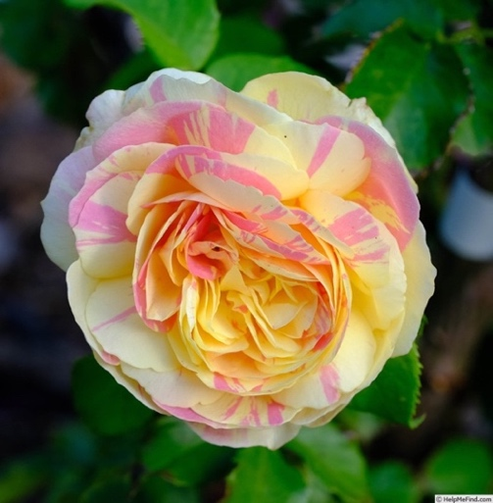
Pop Art – Grandiflora NEW (2021 +)
Zone5-10 by Christian Bedard
Height:
2-4½'
Spread:
1½-2½'
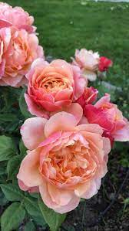
Large very full 4-4½" Flowers striped pink and yellow, 60-75 petals, moderate fruity fragrance, glossy green foliage, cupped blooms, fruity fragrance, Blooms in flushes throughout the season. Ovoid, rounded buds.
https://lincolnnurseries.com/plant/R5265/
https://www.naturehills.com/pop-art-rose
State of Grace– Grandiflora (2019 8.0)
Zone 6-9 by Christian Bedard
Height: 3-4'
Spread: 2½-3'
Grandiflora- 3½-4’ buds open to old fashioned spiraled double flowers that are soft apricot-gold with a dark pink reverse, 30-65 petals, moderate fruity fragrance, glossy green foliage.

https://www.edmundsroses.com/product/E24211/11
https://www.regannursery.com/rose/Rosa-Grandiflora-State-of-Grace-New-2020

Floribunda

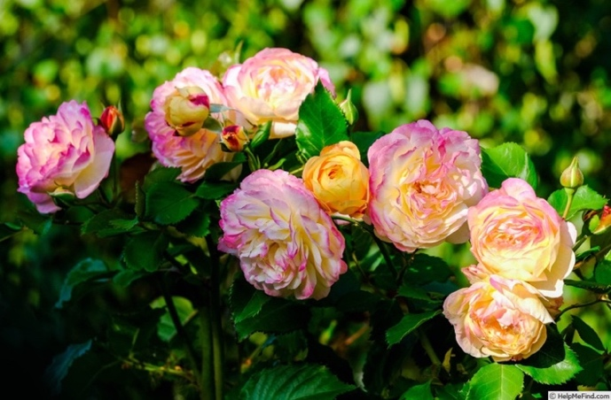
Life of the Party-Floribunda (2018 7.8)
Zone 5-10 by Tom Carruth
Height:
3-3½'
Spread:
1½-2'
Yellow blend very full, Disease resistant, glossy green foliage provides the perfect canvas for the enchanting clusters of blooms that appear in various combinations of yellow, red, pink, and white. 3-4” blooms.

https://lincolnnurseries.com/plant/R5043/
https://www.heirloomroses.com/life-of-the-partytm.html

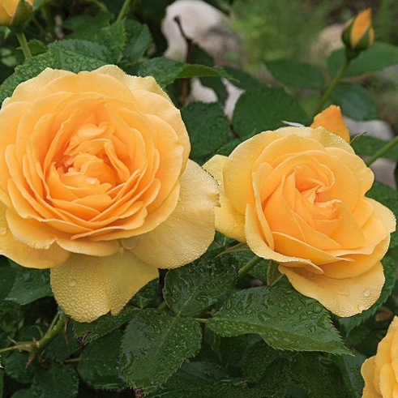
Julia Child – Floribunda (2005 8.3)
Zone 5-9 All American Rose Selection Winner
Height: ARS Members Choice Award
2-2½' by Tom Carruth
Spread:
1½-2'

3 ½” buttery bold blooms and a licorice-clove fragrance, its namesake would have loved in the kitchen, 35+ petals, continually blooming and covered with blooms, and very glossy green foliage.

https://www.heirloomroses.com/julia-childtm.html
https://www.weeksroses.com/product/julia-child/roses

Hybrid Tea Roses

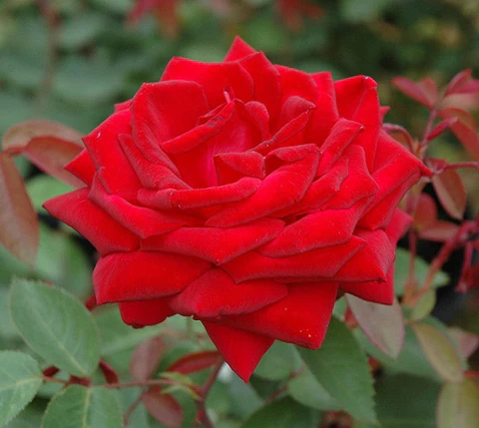
Kashmir EASY ELEGANCE Hybrid Tea Rose (2009 7.8)
Zone 4-9
Height:
3-4'
Spread:
2-3'
3" Red wine colored flowers, 50 petals, glossy green foliage with new growth being velvety red, recurrent bloomer. Velvety red blossoms are as soft as cashmere and beg to be cut for the vase. Rounded habit suitable to a low hedge
https://lincolnnurseries.com/plant/a0058/
https://easyeleganceroses.com/product/kashmir-rose/
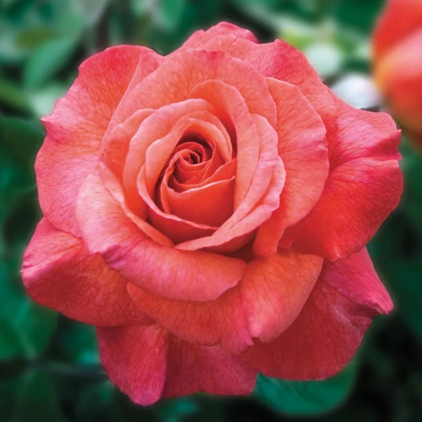
Sedona Hybrid Tea (2008 7.5)
Zone 5-10 Jackson Perkins Rose of the Year 2010
Height: by Keith Zary
5'
Spread:
3-4'
5″ Coral blended sturdy high-centered blooms, have pink undertones on cool nights, 25-30 petals, matte dark green foliage, strong pear scent. Long lasting blooms.

https://www.jacksonandperkins.com/sedona-hybrid-tea-rose/p/v1250/
https://lincolnnurseries.com/product/r5436/

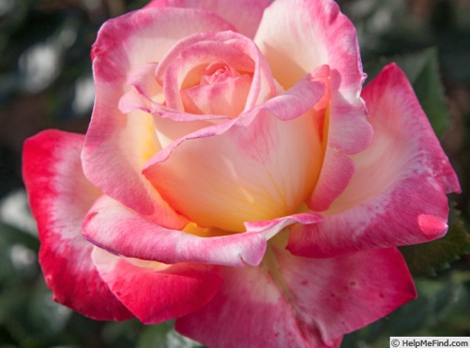
Enchanted Peace Hybrid Tea Rose (2020 +)
Zone 6-11 Meilland
Height:
4½-5'
Spread:
2-3'
Bicolor, warm yellow blooms edged in pink, strong fragrance, good disease resistance, dark green very glossy foliage, blooms in waves continuously over a long season, good for cuttings and containers.
https://www.starrosesandplants.com/plants/enchanted-peace/
https://www.edmundsroses.com/product/E23682/13
https://lincolnnurseries.com/plant/R5480/
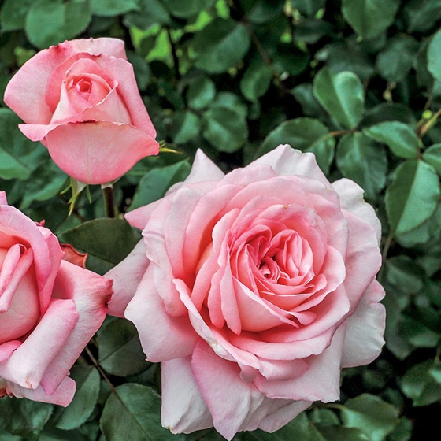
Savannah Sunbelt – Hybrid Tea (2014 7.9)
Zone 6-11 Biltmore Best fragrance and Best overall HT
Height: Kordes 2013
3-4’
Spread:
2-3’ Abundant 4 inch fragrant salmon pink, very full, blooms. Blackspot, mildew and disease resistant, glossy green foliage. Named Best Hybrid Tea, Most Fragrant Rose and Most Outstanding Rose at the Biltmore International Rose Trials in 2015.
https://lincolnnurseries.com/plant/r5418/
https://www.edmundsroses.com/product/E24179/13

Ingrid Bergman Hybrid Tea Rose (1981 8.4)
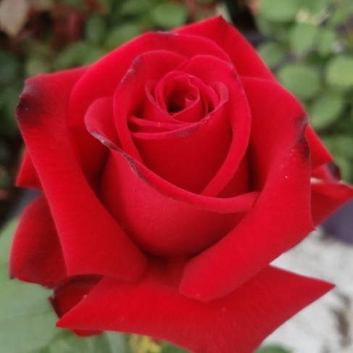
Zone 4-9 Award of Garden Merit – Royal Horticultural Society
Height: World Federation Rose Society Hall of Fame 2000
3-4' by Pernille and Mogens Olesen
Spread:
2-3'
5-5½" Bright red flowers have velvety petals 35-40 petals, dark green foliage, strong sweet anise rose fragrance. Dark green foliage. Holds well in heat blooming early summer until frost. Some disease resistance but will probably require spray regimen care.
https://lincolnnurseries.com/plant/r0114/

https://www.starrosesandplants.com/plants/ingrid-bergman/

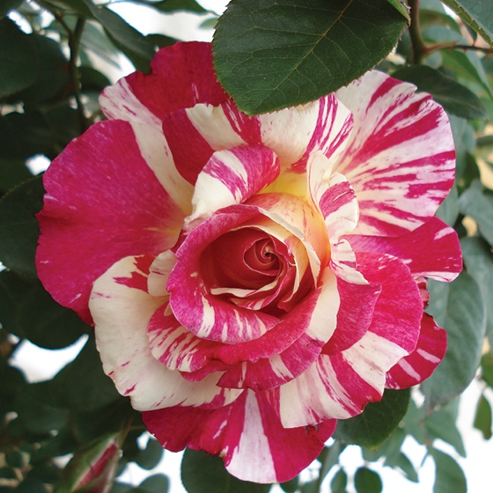
Maurice Utrillo Hybrid Tea Rose (2004 %)
Zone 5-9 by Georges Delbard
Height:
4-5'
Spread:
4-5’
Red, white, and yellow splashes of color. Part of the Painters collection. 3-4” cupped blooms, moderate fragrance, lush glossy green foliage, excellent repeat, disease resistant and easy to care for.
https://www.regannursery.com/rose/Rosa-Hybrid-Tea-Painters-Collection-Maurice-Utrillo
https://www.thefragrantrosecompany.co.uk/maurice-utrillo-rose
https://www.edmundsroses.com/product/E23975/13
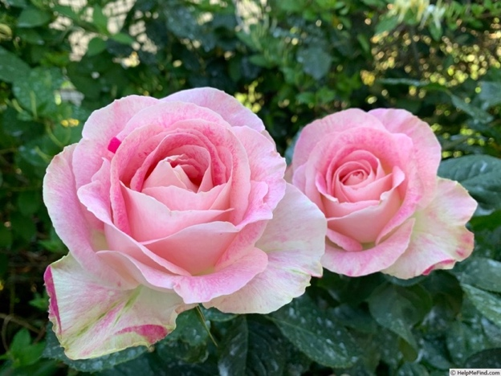

Painted Porcelain’ Hybrid Tea Rose NEW 2021
Zone 4-9 by Christian Bedard
Height:
3½-5'
Spread:
3-4'
White, pink streaks, stripes, flecks, cream reverse, ages to pink . Mild, fruity, tea fragrance. 25 to 30 petals. Average diameter 3.75". Double (17-25 petals), borne mostly solitary, classic hybrid tea bloom form. Vigorous upright bushy habit, Blooms in flushes throughout the season.
https://lincolnnurseries.com/plant/R5430/

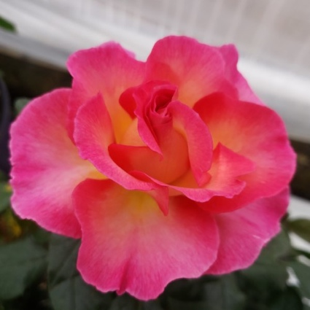
https://www.edmundsroses.com/product/E24081/13

Julie Andrews Hybrid Tea Rose (2020 +)
Zone 6- 9 by Delbard 2020
Height: ‘Most Beautiful Rose of the Century’ International Rose Competition
2-4'
Spread:
2-3'
Compact Hybrid Tea - 4-5" Flowers are intense fuchsia pink with a yellow base and golden yellow reverse, 30 petals, dark green foliage, upright bushy habit, strong anise rose fragrance, very disease resistant
https://www.heirloomroses.com/julie-andrews.html
https://lincolnnurseries.com/product/r5423/
https://www.edmundsroses.com/product/E23868/13
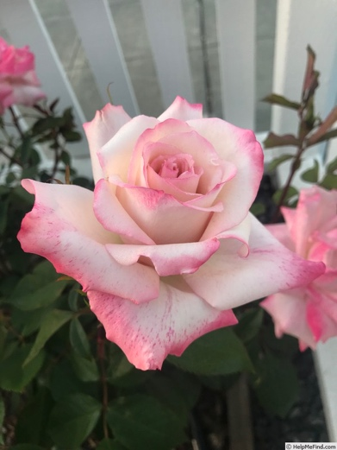
PINKERBELLE™ Hybrid Tea Rose (2018 (8.1))
Zone 5-9 Rose Hills Memorial Park International Rose Trials
Height: by Meilland
5-6'
Spread:
3-4'
Pink. Strong fragrance. 42 to 47 petals. Average diameter 4.25". Large, very full (41+ petals), borne mostly solitary, in small clusters, cupped bloom form. Blooms in flushes throughout the season. 4" Cream flowers are suffused with tones of pink and lavender, and finished with a pink picotee edge,
https://lincolnnurseries.com/plant/R5410/
https://www.starrosesandplants.com/plants/pinkerbelle/

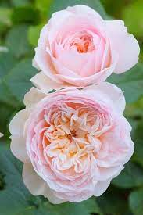
David Austin Roses

Emily Bronte - English Shrub Rose (2019 +)
Zone 5-11 DA Best for Fragrance Award
Height: DA Best for Health Award
4'
Spread:
3½'
Soft pink and apricot flowers, 106 petals, intense tea scent with delicious hints of lemon and grapefruit. An exceptionally beautiful rose; the distinctive blooms are very neat and rather flat. Each bloom is a lovely soft pink, with a subtle apricot hue, the smaller central petals deepening to rich apricot and surrounding a button eye, which unfurls to reveal deep-set stamens. It forms a bushy shrub with strong, healthy, upright growth.
https://lincolnnurseries.com/plant/r4202/
https://www.davidaustinroses.com/products/emily-bronte
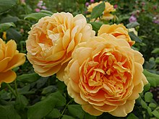
Golden Celebration – English Shrub Rose (1993 8.1)
Zone 5-11 DA Best for Fragrance Award
Height:
4-4½'
Spread:
4-4½'
Deep yellow. Strong, sweet fragrance, sauterne wine and strawberry. 55 to 75 petals. Average diameter 2.75". Medium, very full (41+ petals), borne mostly solitary, in small clusters, cupped, globular bloom form. Blooms in flushes throughout the season. Rounded buds.
https://www.davidaustinroses.com/products/golden-celebration
https://www.heirloomroses.com/golden-celebrationr.html
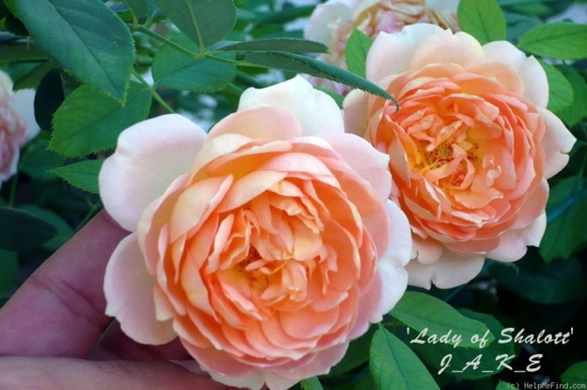
Lady of Shallot (2010 7.9)
Zone 4-11 DA Best for Flowering Award
Height:
5'
Spread:
3½-4'
Red orange buds open to orange petals shading to salmon-pink outer petals with golden-yellow reverse. Strong apple, clove, tea fragrance. Large blooms, 3.5”, 60 petals, cluster-flowered, in small clusters, chalice shaped bloom form. Blooms in flushes throughout the season. Full to partial sunlight.
https://www.davidaustinroses.com/products/lady-of-shalott
https://www.heirloomroses.com/lady-of-shalott.html
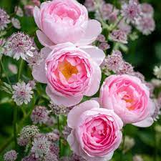
Scepter’d Isle - English Shrub Rose (1997 8.3)
Zone 4-11 DA Best for Flowering Award
Height: DA Best for Fragrance Award
5'
Spread:
4'

Soft pink shading to a paler pink on the outer petals. Strong, myrrh fragrance, 45 petals. Average diameter 3.5". Medium, double, cupped bloom form. Prolific, continuous (perpetual) bloom throughout the season. Full to partial sunlight, Tolerant to shade
https://www.davidaustinroses.com/products/scepter-d-isle
https://www.heirloomroses.com/scepter-d-isler.html
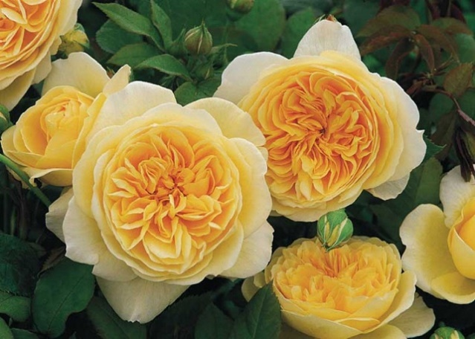
Teasing Georgia – English Climbing Rose (1998 7.7)
Henry Edland Medal for best-scented
Zone 5-10
Height:
8-12'
Spread:
3-3½'
Large free flowering cupped deep to light yellow blended flowers, 110 petals, strong licorice fragrance, medium green foliage. Full sun medium climber.
https://www.gardenia.net/plant/rose-teasing-georgia-ausbaker
https://www.davidaustinroses.com/products/teasing-georgia-climbing-rose
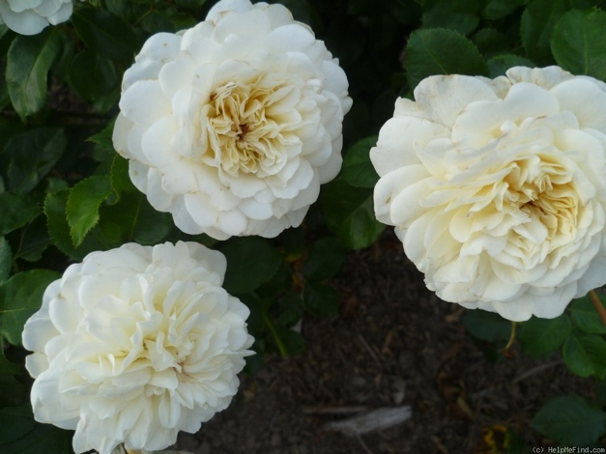
Tranquillity – English Shrub Rose (2014 7.7)
Zone 5-11
Height:
3½-4'
Spread:
3½-4'
Light yellow, ages to white. Mild, apple fragrance. Average diameter 3.5". Large, very full (41+ petals), borne mostly solitary, in small clusters, cupped, globular, rosette, scalloped bloom form. Blooms in flushes throughout the season. Rounded buds.
https://lincolnnurseries.com/plant/R4207/
https://www.davidaustinroses.com/products/tranquillity
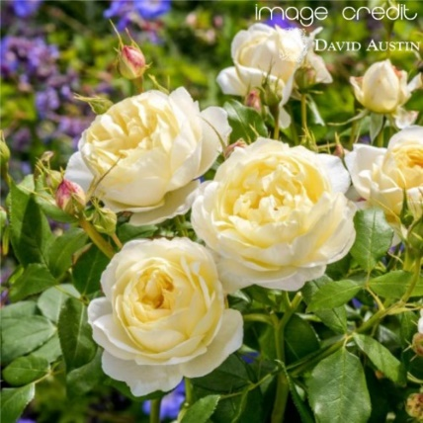
Vanessa Belle - English Shrub Rose (2018 +)
Zone 5-11 DA Best for Flowering Award
Height:
3½-4'
Spread:
2½-3'

Pale yellow from pink tinged buds, fade to cream with age, medium bushy upright shrub, green tea, lemon honey fragrance. Large blooms, 110 petals, blooms continuously. Good for containers, good cutting rose.

https://lincolnnurseries.com/plant/r4213/
https://www.davidaustinroses.com/products/vanessa-bell

